Archipelago of the Azores – Program for disabled travelers
Program 5 days in São Miguel

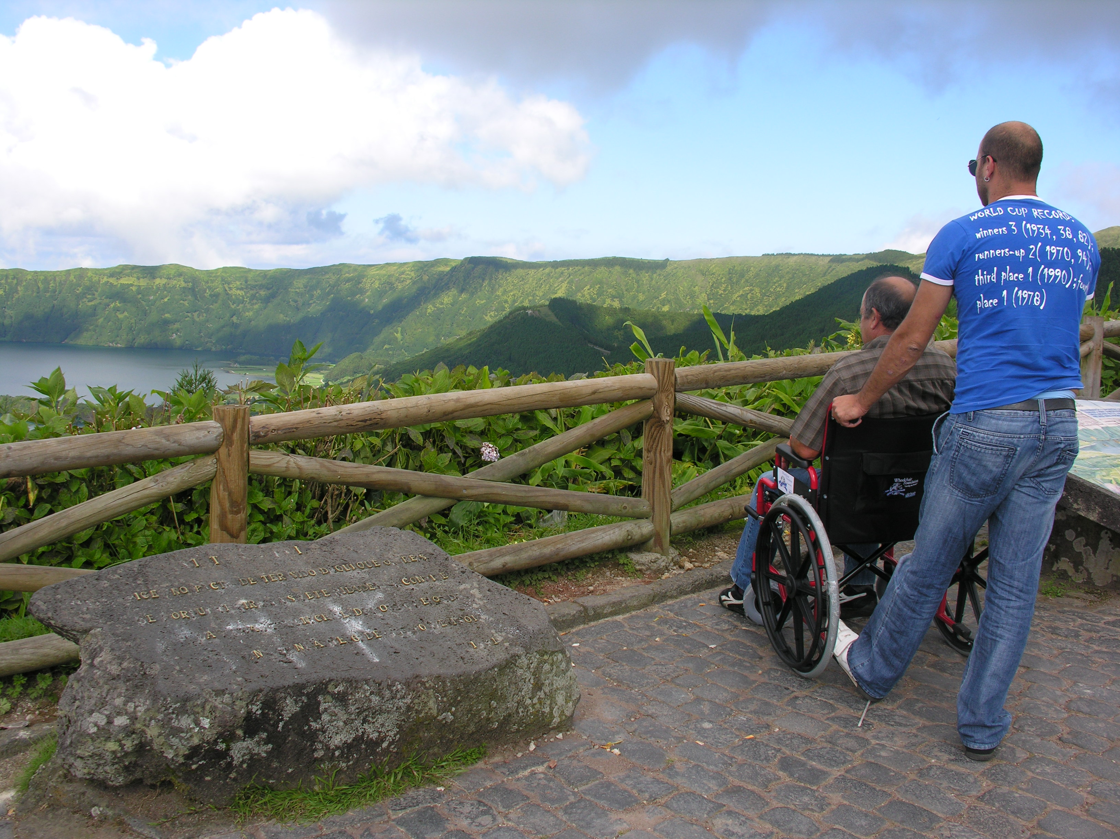
Our program includes:
- Transfer airport/hotel/airport or aiport/hostel/airport;
- 5 days/ 4 nights in a Hotel Ponta Delgada 3 * (double rooms with wc), or in Lagoa hostel (double room with WC, 5m by car from Ponta Delgada), both with breakfast included;
- Insurance during the five days stay (doesn’t included flight insurance);
- 3 half day tours (03h30) or 1 half day tours and 1 full day tour (07h30), chosen from our collection, with guide included.

Conditions:
Our packages are calculated for 2, 4, 6 or 8 persons. Minimum of 2 persons.
If you wish to reserve the flight please contact www.sata.pt.
The prices are with VAT included.
Further excursions are optional and can be booked with us.
All excursions are without lunch included.
All excursions are with wheelchair accessible vehicle.
Each extra hour for the tours will be plus 17.50€.

Full service package –
Prices per person – 289.80€ (hotel accommodation)
Prices per person – 240.60€ (hostel accommodation)
Prices from April do September 2013.

Tours
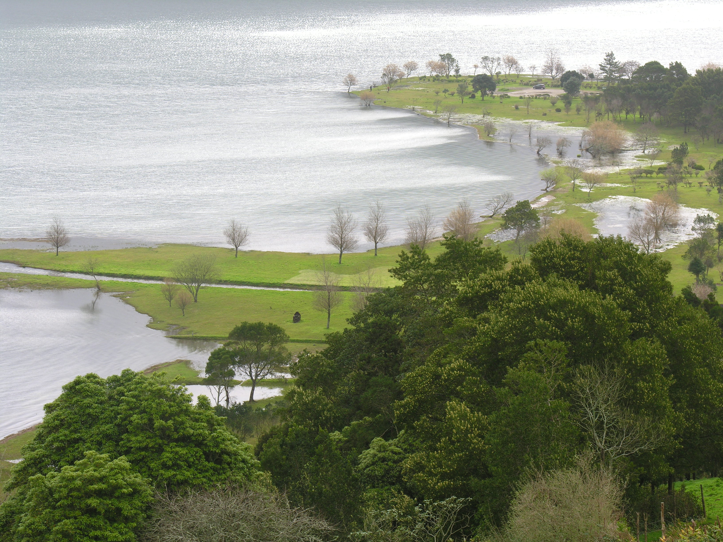
Sete Cidades - This half day excursion leads you to one of the Seven Wonders of Portugal – Lagoa das Sete Cidades. You will enjoy a wonderful tour on a accessible vehicle to the blue and green lake, passing threw some amazing viewpoints such as Escalvado viewpoint, Lagoa de Santiago, King´s view, carvão viewpoint and also the village of Sete Cidades. In the volcanic complex of Sete Cidades you can observe a unique landscape where the green mountains give a joyful atmosphere to the rural village of Sete Cidades.

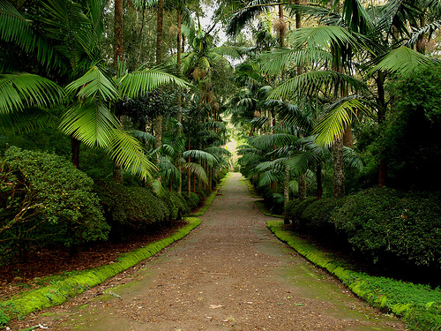
Furnas - This full day tour to Furnas will take you to the lagoa das Furnas where you can see the Furnas Stew, a typical meal cooked with the steam coming from the active volcano; caldeira das Furnas, with 22 thermal springs waters; a botanical Garden called Terra Nostra, full of endemic plants such as 200 types of camellias, fern garden, azalea woods. Finally, the thermal baths of Poça da Beja will delight your stay.

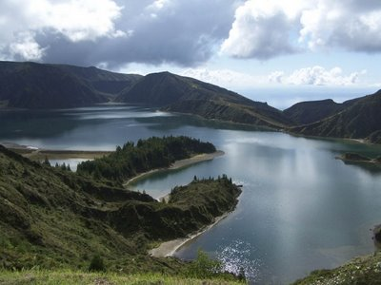
Lagoa do Fogo – This half day tour will give you the possibility to observe the Lagoa do Fogo, a volcanic crater with 1.5km of area, with endemic plants such as laurel, Azorean bilberry trea, trea heath. It´s also possible to see some birds in Lagoa do Fogo, specially, seagulls and common terns. After a small stop in the city of Ribeira Grande where you can visit the Senhor dos Passos church, a final example of baroque architecture, you will continue in the north coast of the island to visit a unique green tea factory in Europe – Gorreana.

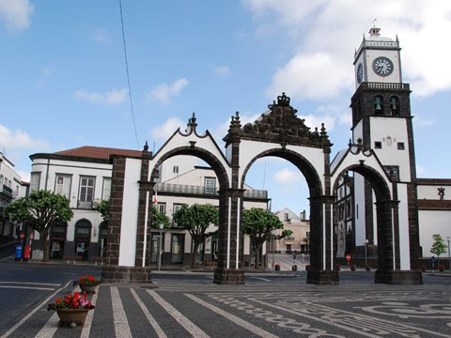
Ponta Delgada – This half day tour to the capital city of Ponta Delgada will give you the possibility to visit many interesting and historical places of the city, such as San Sebastian church; the sanctuary of Esperança, where it takes place the most important religious festivity of the Archipelago – Santo Cristo dos Milagres; the city gate of Ponta Delgada, the local market, the Colégio Church and finally António Borges Garden, a final example of botanical gardens.

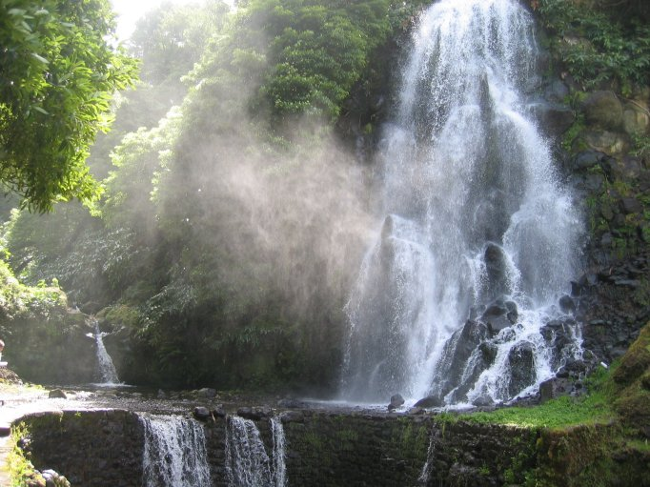
Nordeste – This full day tour will take you to a fantastic experience in this green island, with the following stops: santa iria viewpoint; ribeira dos caldeirões, a lovely waterfall surrounded by hydrangeas and azaleas; the village of Nordeste, considered the garden of Europe; Ponta do Sossego and Pôr do Sol viewpoint.

Adventure and trekking in Sete Cidades
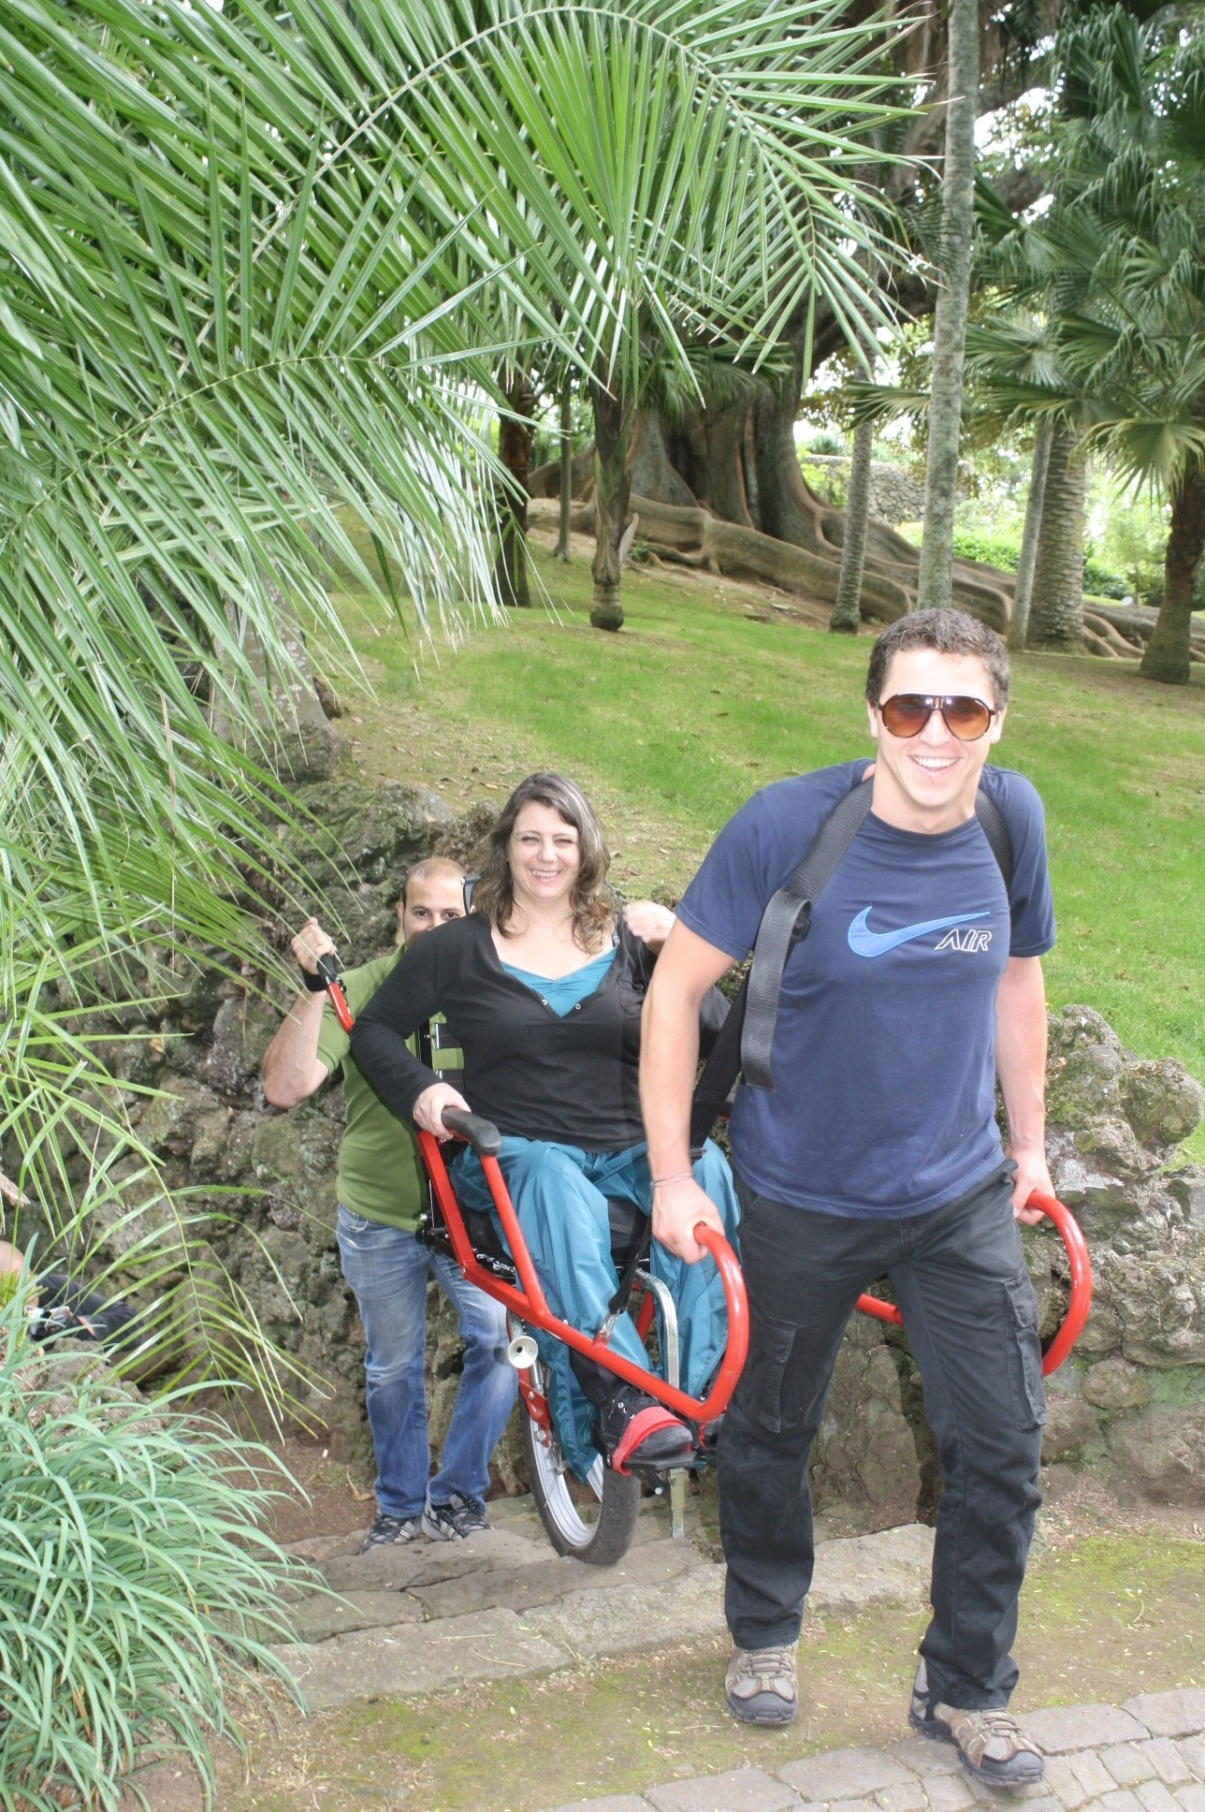
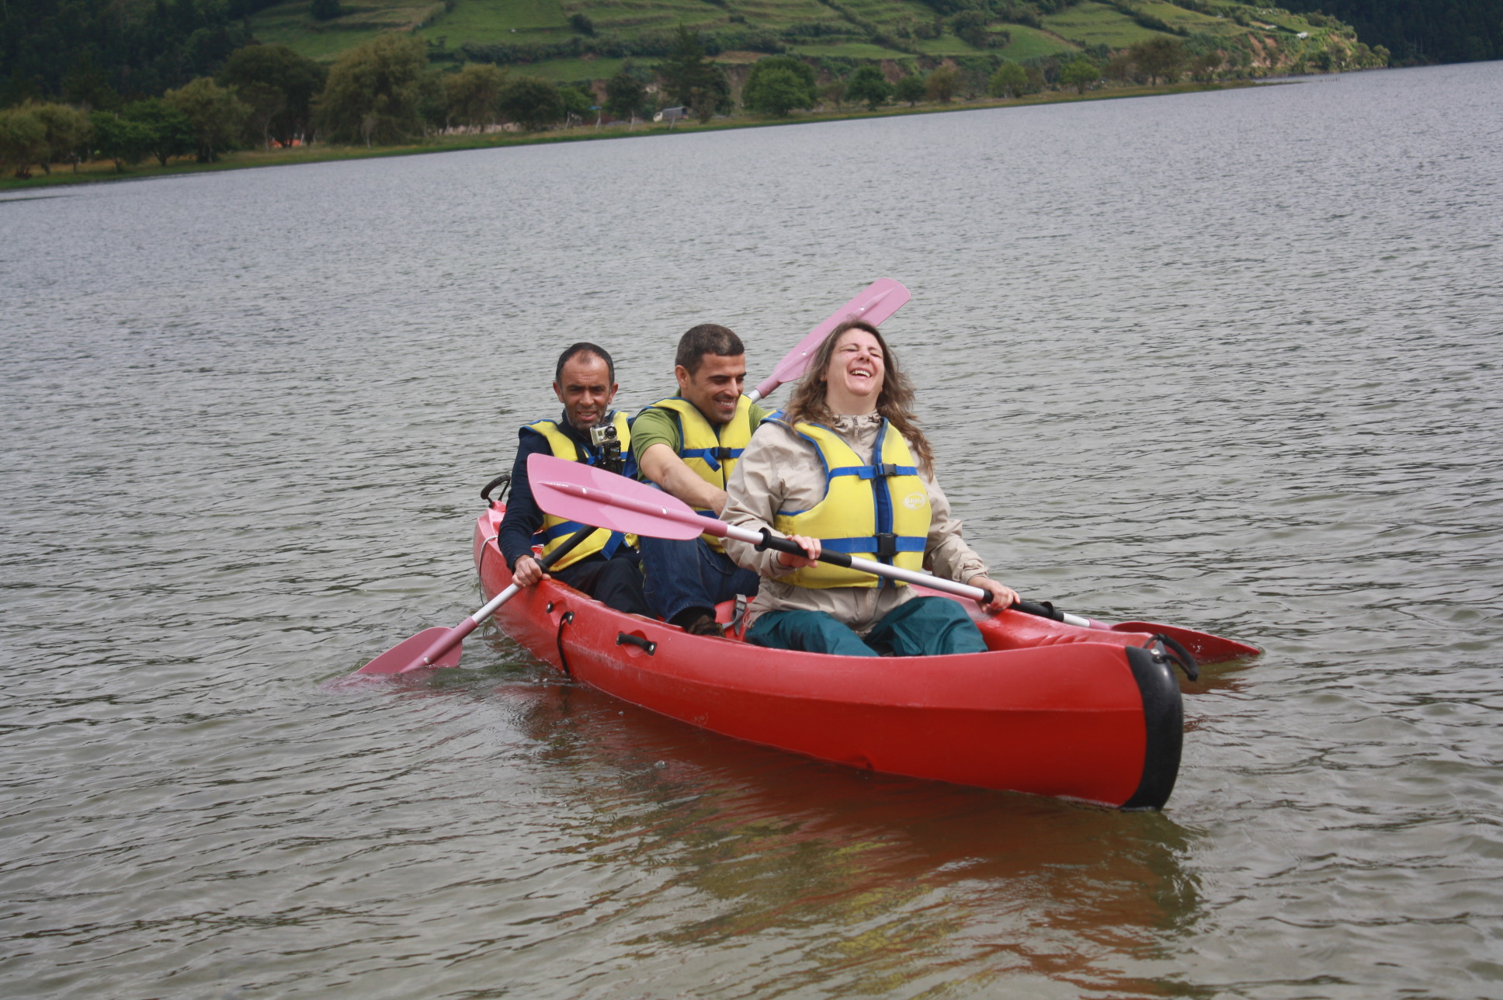
This full day excursion will give you the possibility to experience nature activities. Canoeing in Lagoa das Sete Cidades and a pedestrian walk in the joellete (a appropriate chair for disabled people do pedestrian walks) among the blue and green lake of Sete Cidades.

