Mediate Project
Good Practice Guide
Questionnaire

(Revised Draft Text following discussion at Working Group Meeting in Nurnberg 16th/17th September 2009)

Introduction

What is this about?

We are contacting you as a city or area which has been identified as demonstrating good practice in improving the accessibility of your transport systems.

Who are we?

The Mediate Project is part of the 7th Framework Programme of the European Commission. The aim of the Project is to establish a common European methodology for measuring accessibility to urban public transport. We believe that this will help all of us in Europe to plan and deliver accessible transport systems more effectively and more consistently in future. You can find out more about the Project and its partners at www.mediate-project.eu.

What do we want to know?

One of the key outputs from the Project will be a Good Practice Guide. The Guide will draw on experience from cities around Europe and look at what they have done, what makes them successful and what lessons can be drawn from their success that can be applied to help other cities and areas.

We would like you to tell us the aspect or aspects of your public transport system that you believe have made a significant difference to the mobility of disabled and older people. In particular, we want to know:

- What you have achieved;
- How you have achieved it and
- How it makes a difference to the mobility of disabled and older people.

We want to identify examples of good practice in a number of different areas, all of which are key to successful delivery:

- Accessible information and communication systems (for example initiatives to help disabled and older people with pre-journey planning; initiatives to provide information during the journey in forms and media that are accessible);
- Level access through transport systems (for example, barrier free routes to enable wheelchair users and others to travel independently from home to their destination using the pedestrian environment and public transport);
- Staff training (for example, training of all staff in disability awareness and disability equality issues);
- Travel training for passengers (for example, familiarisation sessions or escort schemes to enable disabled or older people to build up the knowledge and the confidence to travel independently);
- Passenger feedback and monitoring systems (for example, involvement of end users in providing regular feedback to managers about how effective the system is);
- Ticketing systems (for example, systems that allow passengers to transfer between modes without complex activities such as ticket validation which may be inaccessible);
- Infrastructure/Pedestrian environment (for example, initiatives to improve accessibility of public space (including streets and pavements) and of public buildings and facilities to promote accessibility and increase the potential for disabled and older people to use public transport);
- Organisational/policy (for example, a clear policy of your organisation or area to promote accessibility in the transport environment or a structure or management tool within your organisation that enables accessibility issues to be addressed effectively);
- Leadership/Vision (for example, a strategic initiative taken at senior level in your organisation which has made accessibility a clear priority and has enable effective progress to be made).

We are hoping to gather examples of good practice from both large urban areas and from medium/small cities and towns.

We are not trying to benchmark good practice, rather to illustrate some of the approaches that have worked well.

The Mediate Project has adopted the principles of Total Quality Management (TQM) as its approach to good practice because we believe this is the best way to ensure that there is a systematic process for planning and for evaluating success.

We recognise, however, that there may be examples of good practice that are still evolving and we would not want to exclude them. We are therefore looking for projects and initiatives under any of the following four stages of development:

- Ad hoc approach: i.e. a project or development which has been introduced in response to a particular local need or initiative but which is not yet fully evaluated (for example a one-off initiative in response to a specific complaint or problem);
- Isolated approach: i.e. a project or development specifically intended to meet the needs of disabled and older people but which is not yet embedded as part of the transport system (for example an initiative that is self contained and does not link with other parts of the public transport system or other policy areas);
- Systematic approach: i.e. a project or development which has been planned and is being evaluated on a regular basis to ensure feedback from all stakeholders (for example an initiative which has been developed as part of a wider policy and in which end users have been involved from an early stage);
- Integrated approach: i.e. a project or development which has been fully integrated into the public transport network and for which a routine and on-going cycle of monitoring and evaluation (see diagram on next page) is in place.

Please don’t worry if the examples you want to give do not fit neatly into any of these categories. They are intended only for guidance and to help us build up a picture of what makes good practice.

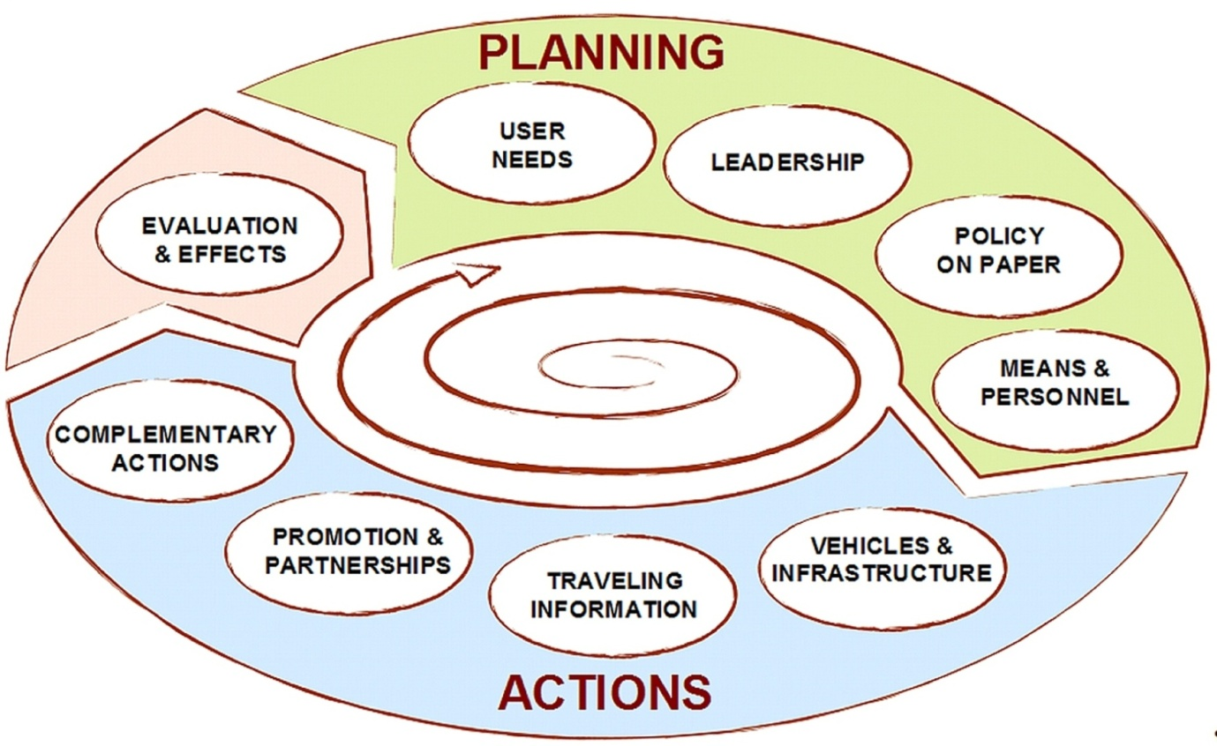The Policy cycle

What will we do with the information you give us?

The questionnaire is being sent to cities and regions across Europe whom we believe have developed interesting and innovative good practice initiatives. The responses will be analysed and reviewed by members of the Mediate consortium and the best examples will be included in a Good Practice Guide to be published as one of the key outcomes of the Mediate Project. It will be used as a tool by other cities and regions working on improving accessibility to their transport systems.

Questionnaire

- About You

Your name ………………………………………………

Your organisation……………………………………….

The main purpose of your organisation...............

..........................................................................................................

Your job title……………………………………………......................................
Your role within the organisation....................................................

Your contact details:

E-mail ……………………………………………………

Phone…………………………………………………….

Your city/area……………………………………………

The population of your city/area………………………..

- About your good practice example/project

2.1 What is the project you want to put forward as a good practice example?

2.1 Which of the categories listed below best describes the project? Please refer to the explanations given on page 2 and tick the box that best describes the example you are giving. Please tick one box only:

- Accessible information and communication systems (including

Journey planning)

- Level access through transport systems (including to/from the pedestrian environment)

- Staff training

- Travel training for passengers

- Passenger feedback and monitoring systems

- Ticketing systems /fare structures/tariff integration

- Infrastructure/pedestrian environment

- Organisational/policy

- Leadership/Vision

- Other (please describe below)

2.2 Who benefits particularly from the project? (Please tick all that apply)

    - Older people

    - Wheelchair users

    - People with walking difficulty
    - Blind people or people with low vision

    - Deaf people or people with impaired hearing
    - People with learning disabilities/cognitive impairments

    - People with mental health problems

    - People with guide or assistance dogs

    - The general public
    - Other (please describe)

2.3 Please tell us what qualitative evidence you have that the project is a success (e.g. feedback from disabled and older people in the area, feedback from drivers, other staff and other sources)

3. Planning

3.1 What is your organisation’s accessibility policy? If it is a written policy please attach a copy. Is there a specific person or group responsible for accessibility? Please describe

3.2 What planning methodology did you use to develop the project (e.g. what steps did you take to work out how the project would be developed, delivered and costed)? Please describe

3.3 Please describe how users (e.g. disabled and older people and other stakeholders) were involved in the planning process. Please describe how stakeholders have been involved (e.g. meetings, consultations etc)

3.4 What are the key objectives of the project, (e.g. was it intended to reduce running time, increase numbers of disabled people able to use public transport etc)? (Please include specific quantitative measures if available)

3.5 What are your success criteria for the project (e.g. how will you know if it is delivering the objective you identified at the start)?

3.6 Using the descriptions on page 3 as a guide, how would you describe the approach you took to develop the project?

3.7 Did you experience any problems or setbacks with implementation of the project? Yes/No (please delete as appropriate)

If you have answered yes, please give details

4. Project Details

4.1 Who runs the project (e.g. public, commercial or not for profit organisation)?

4.2 How long has the project been running? (Please indicate if it is a pilot or a permanent /on-going scheme)

4.3 Please describe the size and scope of the project. (E.g. Does it cover the whole city or a defined part only? Does it involve the whole public transport network or only a defined part of it)? If you have a website with additional details please include the link.

4.4 Was the project introduced as a result of a legal requirement (national, regional or local)?
Yes/No (please delete as appropriate)

If yes, please give details of legislation

4.5 What was the motivation for the project? (E.g. was it a political initiative, lobbying by consumer groups etc) Please give details

4.6 How long has it taken to achieve good practice in this project?

- 6 – 12 months

- >12 months – 3 years

- >3 – 5 years

- More than 5 years

4.7 Does the project involve new infrastructure/vehicles or retrofit and refurbishment? Please give details

5. Funding

5.1 Please indicate the approximate financial scale of the project:
€
a) Capital and start-up costs
€
b) Annual operating costs

5.2 How is the project funded? (E.g. by grant aid, through the fare box, by a combination of funding sources). What is the objective of the funding? Please give details

5.3 Is the funding time limited (e.g. start up costs) or part of an on-going budget commitment? Are there any restrictions on it? Please give details:

6. Monitoring and Evaluation

6.1 How is the project performing against the Objectives as defined in Question 3.4? Please give details

6. 2 What Key Performance Indicators (e.g. quantifiable measurements, agreed beforehand, that reflect the critical success factors of the project such as number of additional passengers, reduction in running time)? Please describe

6.3 Other Quantitative measures

6.3.1 Is there any data on increase in numbers of older and disabled people travelling? Yes/No (please delete as appropriate)

If you have answered yes, please describe what data you have and how it is collected;

6.3.2 Is there any data on reduced dependency on special transport schemes or other forms of support (e.g. home care)? Yes/No (please delete as appropriate)

If you have answered yes, please describe what data you have and how it is collected;

6.4 Qualitative indicators

6.4.1 Please describe your methods for evaluating customer/user satisfaction e.g. Customer surveys, complaints collection and recording, complaint resolution etc.

6.4.2 Have you made any changes to the scheme as a result of the performance measures and / or customer satisfaction indicators?
Yes /No (please delete as appropriate)

If you have answered yes, please describe, and indicate the success of the changes.

6.5 Are there any further benefits from the project e.g. increased usage by other categories of passengers; reduced congestion due to increased use of public transport; environmental benefits?

6.6 Is the management of the project within the scope of a formal Quality Management System (QMS) (e.g. ISO 9000 series)
Yes /No (please delete as appropriate)

If Yes, please describe the QMS as simply as possible

6.7 Please tell us how disabled and older people are involved in monitoring the project (e.g. through user committees, mystery shopping, surveys etc). Please give details (for example how often do user committees meet? what is their scope / remit?)

6.8 Are the outcomes of the project in line with your expectations?
Yes /No (please delete as appropriate)

If you have answered no, please describe how the reality has differed from your expectations

7. The Future

7.1 Please tell us what you think will have happened to the project in 5 years time. Will it be:

- About the same
- Better integrated into the public transport network (please describe)

- Much more extensive (i.e. a larger project or the same project replicated in other areas) Please describe

- No longer running. Please explain why

7.2 If you had the opportunity to start this project again in the light of experience, what would you do differently?

7.3 Do you expect to see more laws, regulations or guidelines in the future in the area of transport accessibility? Yes/No (please delete as appropriate)

8. What next?

8.1 If your project is chosen for inclusion in the Mediate Good Practice Guide, would you be willing to welcome enquiries/visits from (a) the MEDIATE partners and/or (b) other European cities interested in learning from your example? Yes/No (please delete as appropriate)

8.2 The purpose of the Good Practice Guide is to share information. If any of the information you have given us is confidential, and not for publication, please indicate below

8.3 If you have photographs or documents which help to illustrate the project you have described, please send them with your response (Photographs in JPEG format only please)

8.4 Thank you for completing this questionnaire. Please return it to ann@annfrye.co.uk by Thursday 5th November 2009.

