Archipelago of the azores – Program for disabled travelers
Program 7 days in São Miguel and Terceira

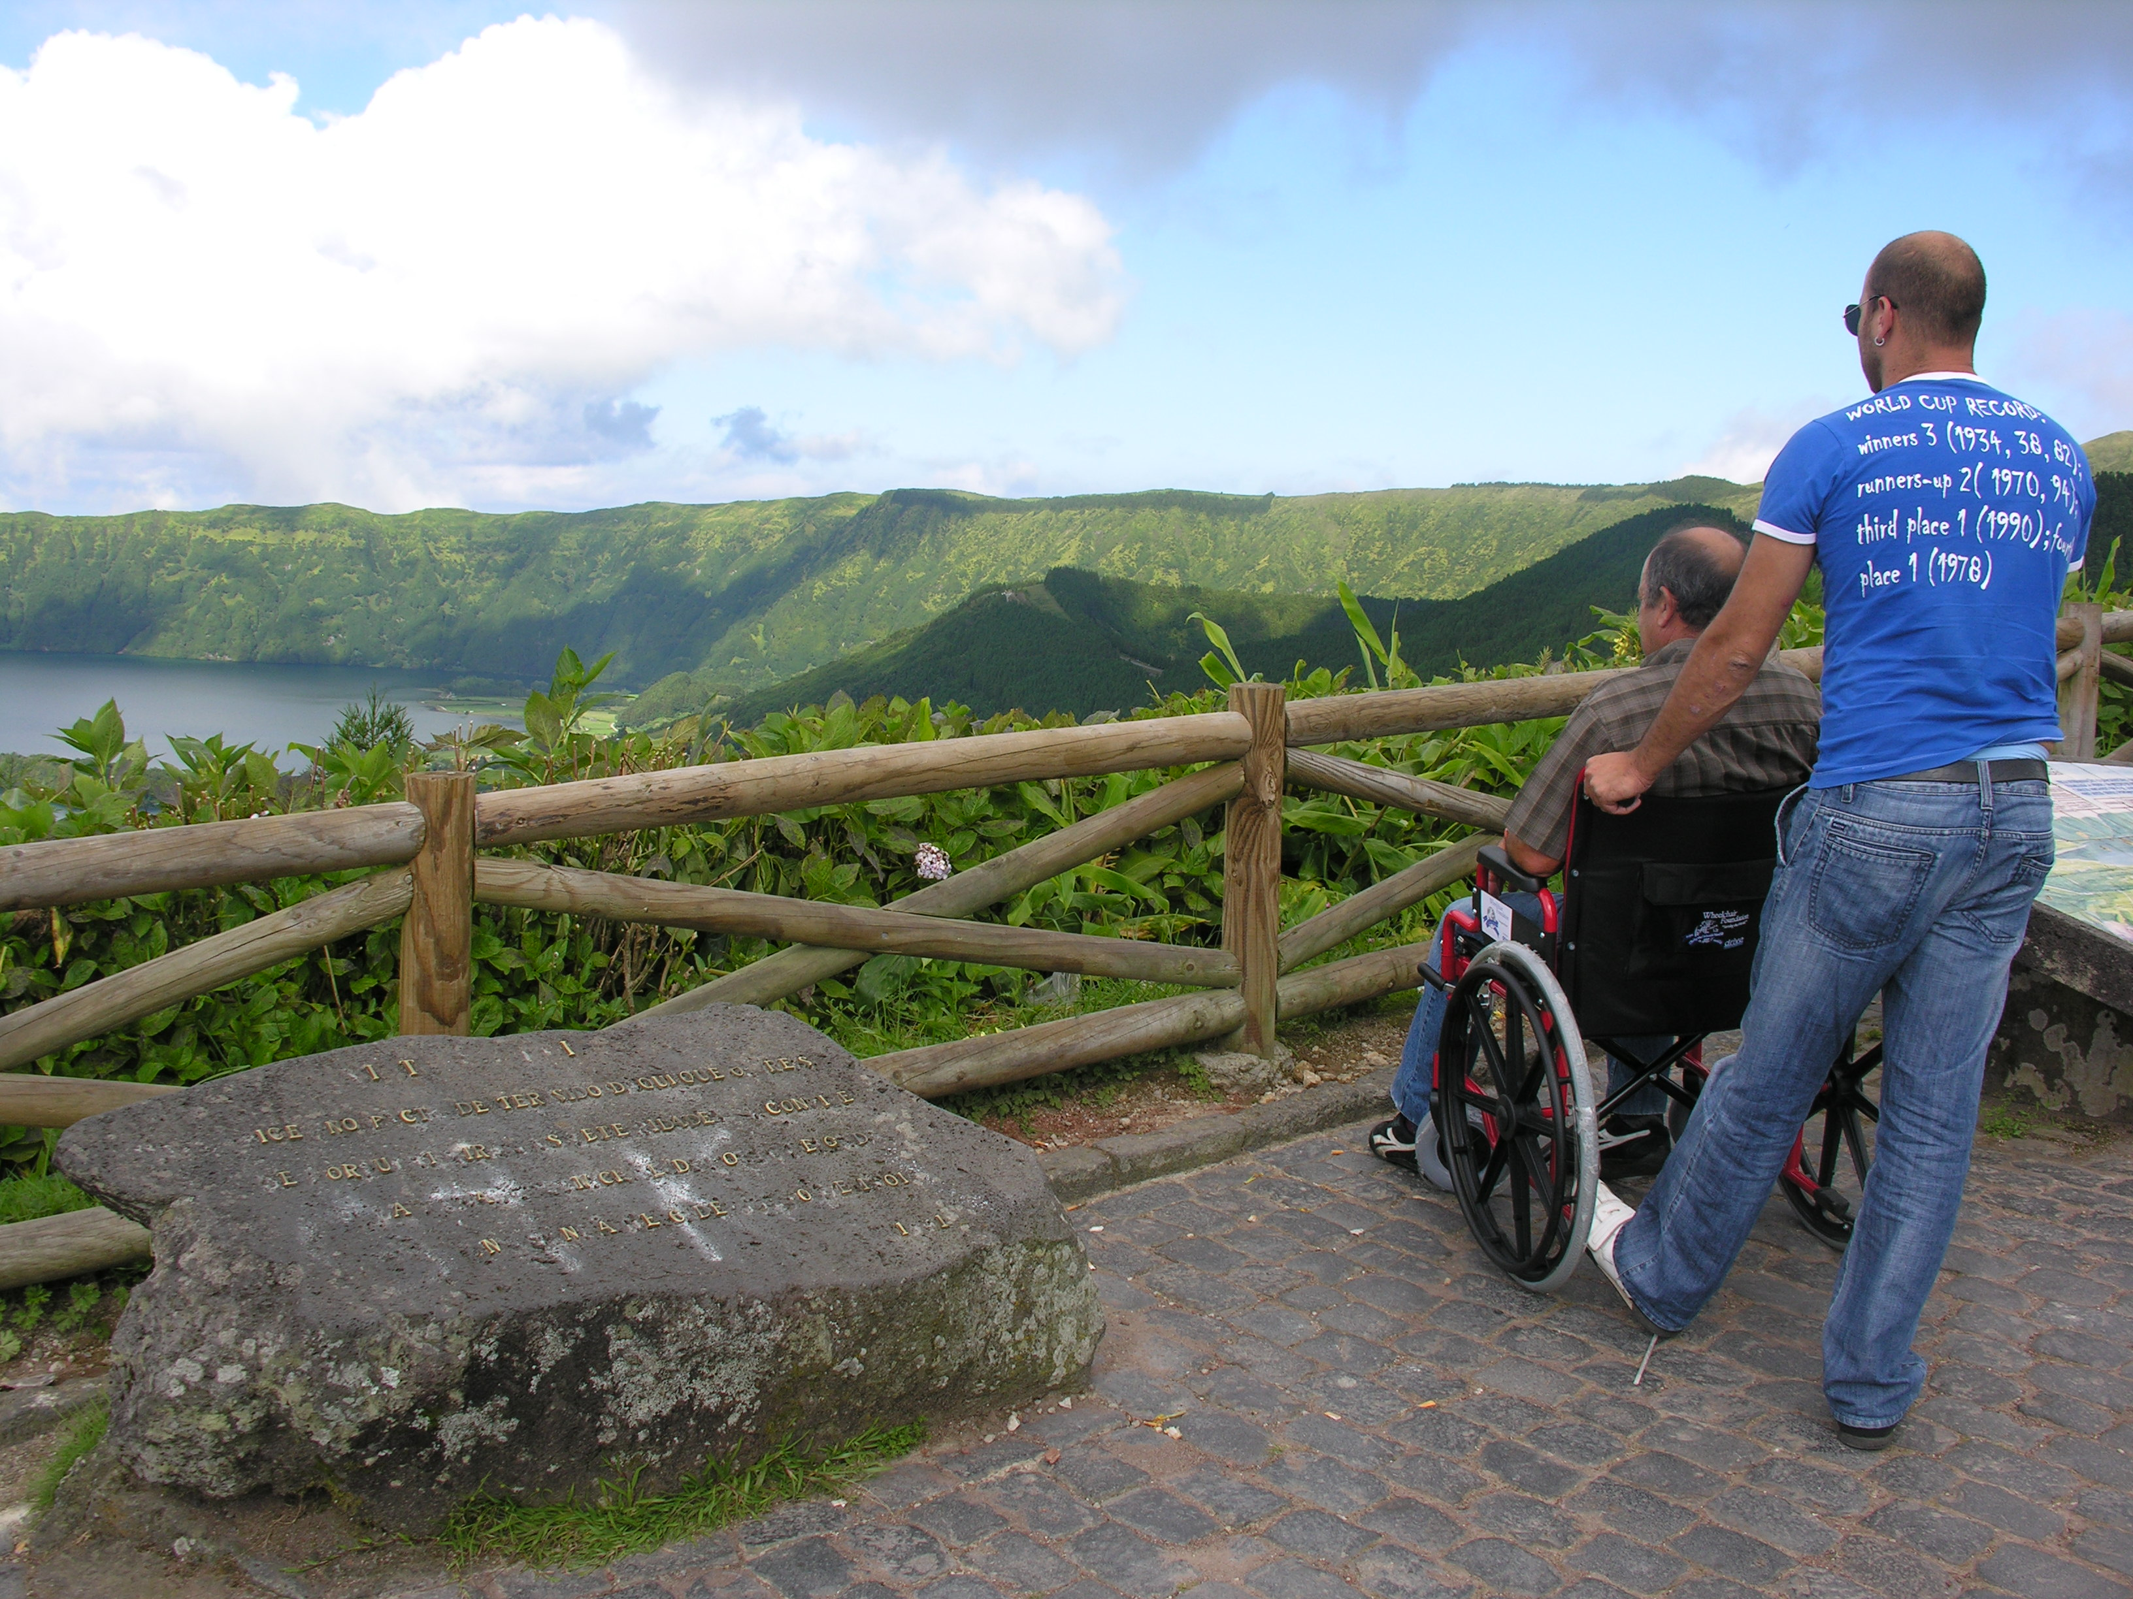
Our program includes:
- Transfer airport/hotel/airport;
- 7 days / 6 nights: 3 nights in Hotel Ponta Delgada 3* (double rooms with wc, in Ponta Delgada city, island of São Miguel) and 3 nights in Angra Garden Hotel, (3*hotel, double rooms, with wc, Angra do Heroismo city, island of Terceira);
- Insurance during the seven days (doesn’t included flight insurance);
- 3 half day (03h30) tours or 1 full day (07h30) and 1 half day tour (chosen from our collection) with guide included, in São Miguel Island;
- 2 half day (3h30) tours in Terceira island or 1 full day tour (07h30), chosen from our collection, with guide included, in Terceira Island;

Conditions:
Our packages are calculated for 2, 4, 6 or 8 persons. Minimum of 2 persons.
If you wish to reserve the flights please contact www.sata.pt.
The prices are with VAT included.
Further excursions are optional and can be booked with us.
All excursions are without lunch included except the half day tour to Quinta do Martelo, in Terceira.
All excursions are with wheelchair accessible vehicle.
Each extra hour for the tours will be plus 17.50€.

Full service package –
Prices per person - 477.90€
Prices from April to September 2013.

Tours in São Miguel
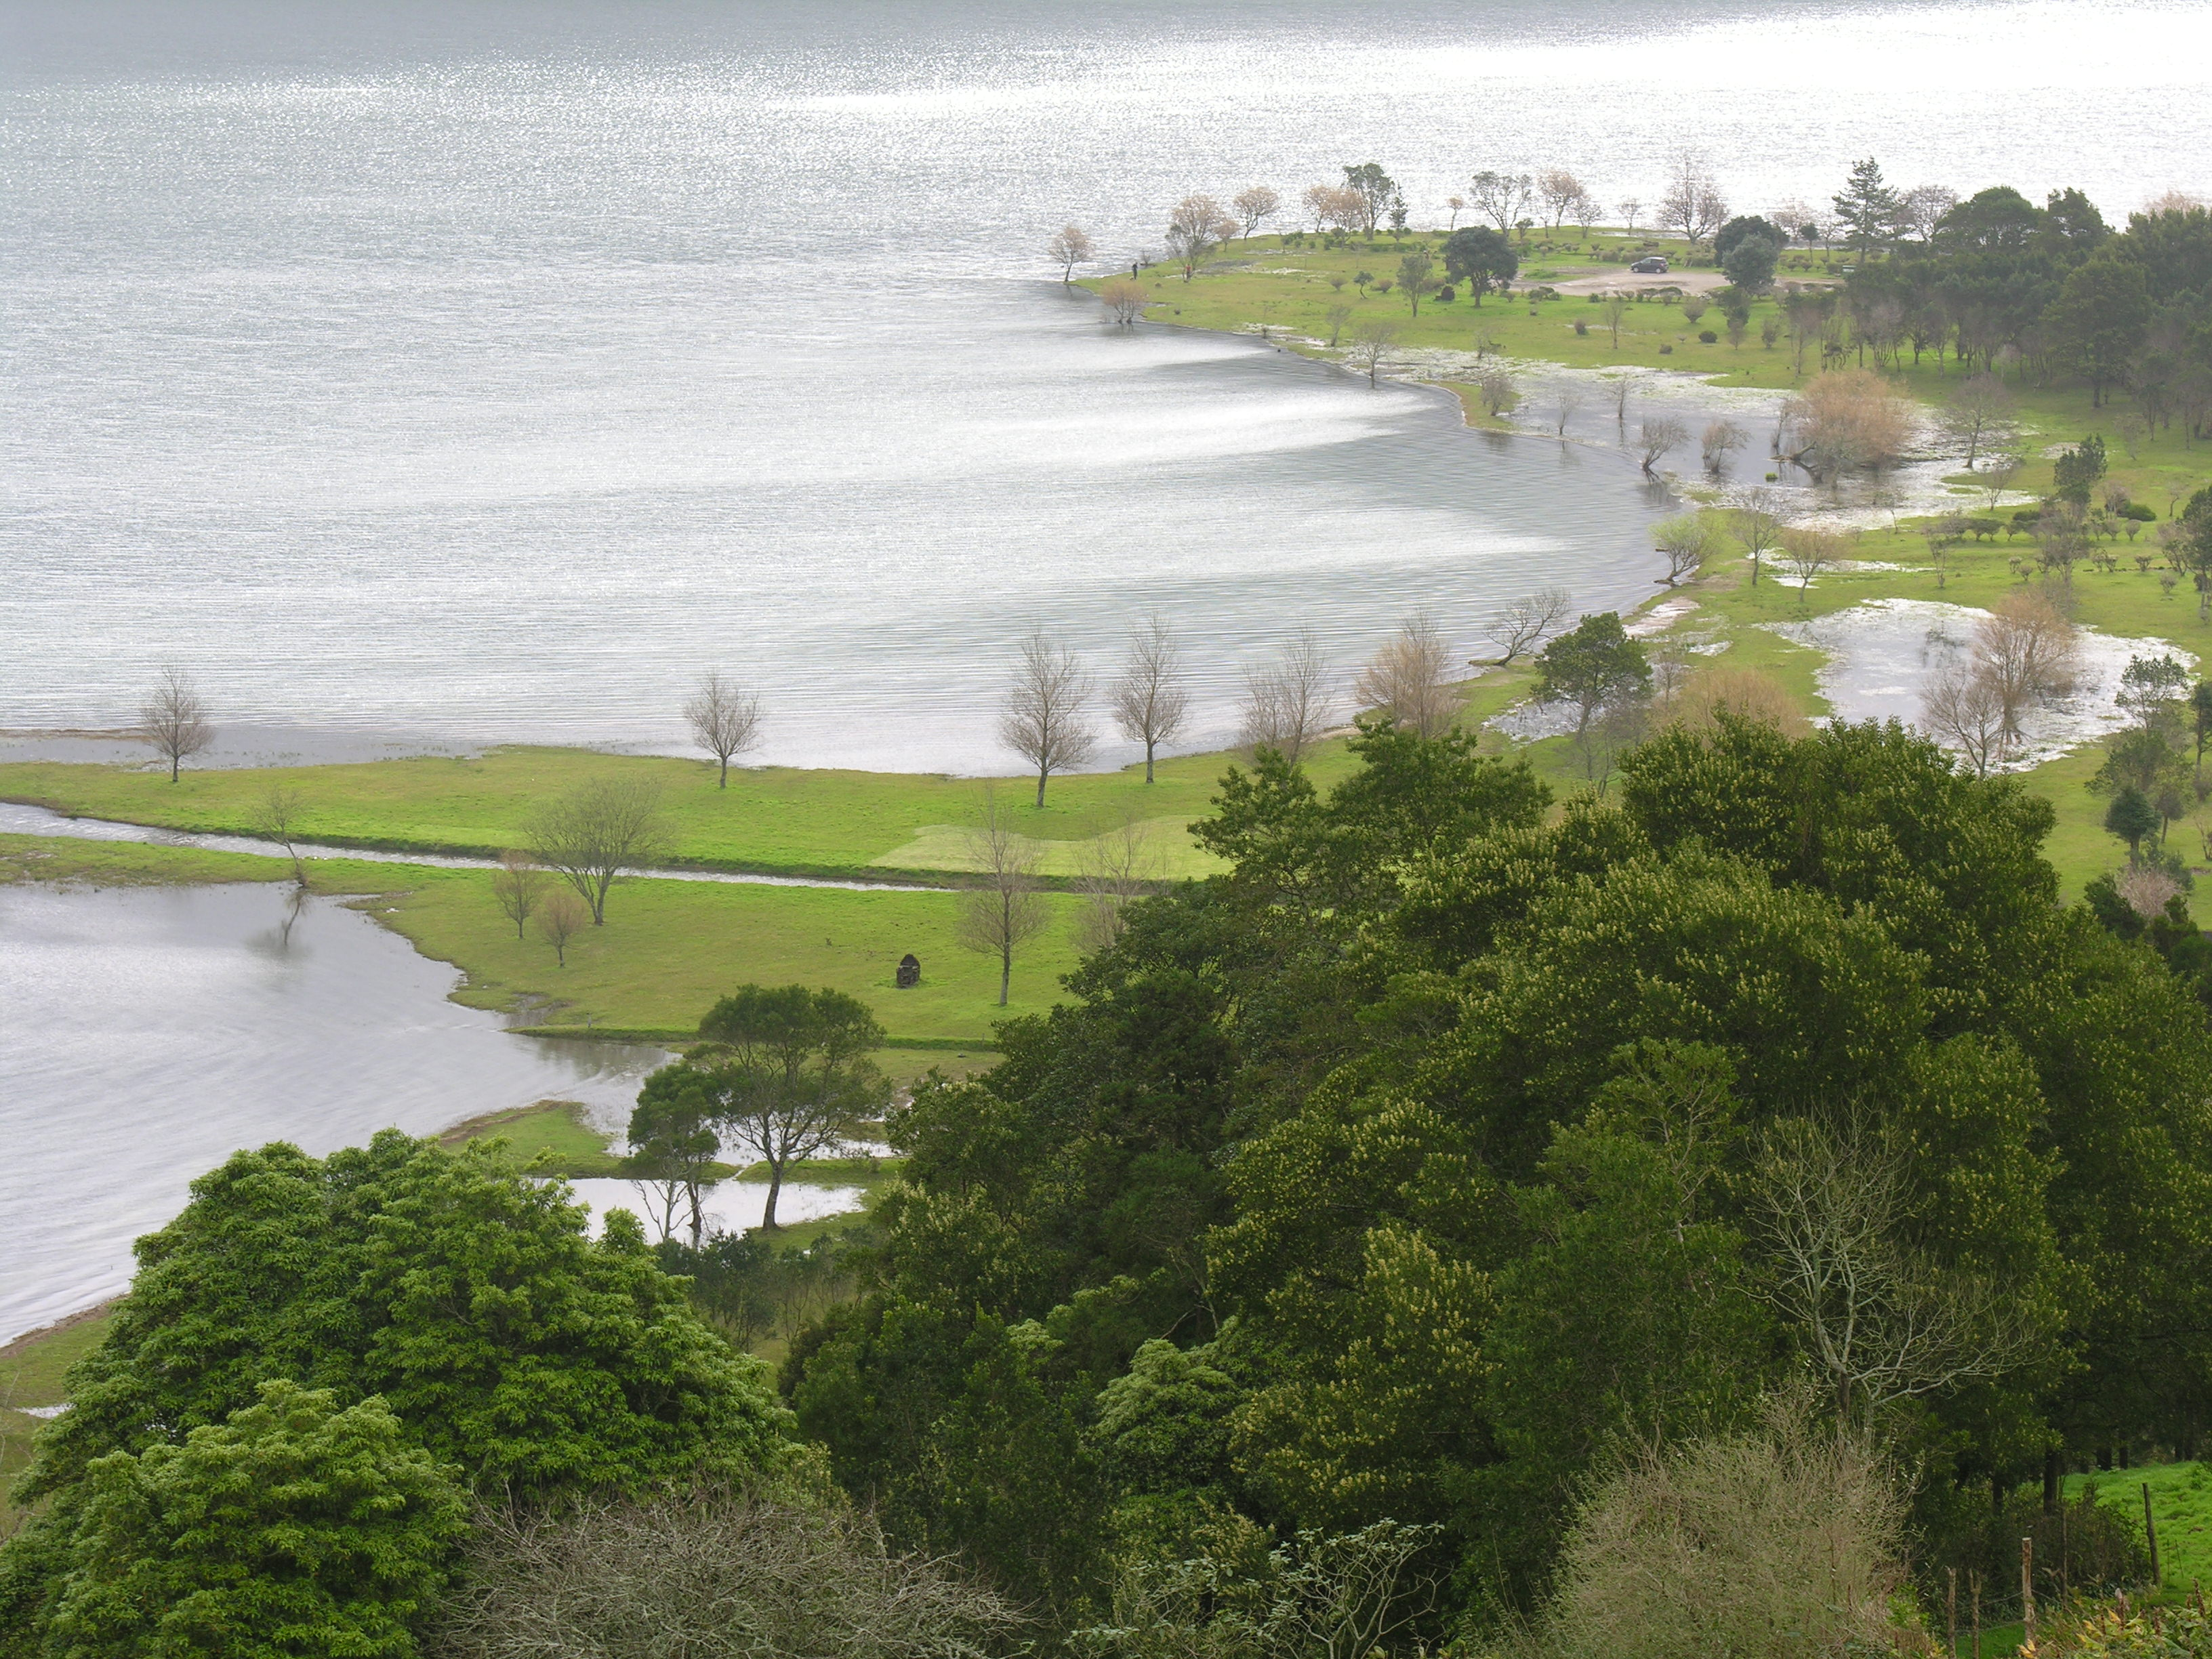
Sete Cidades - This half day excursion leads you to one of the Seven Wonders of Portugal – Lagoa das Sete Cidades. You will enjoy a wonderful tour on a accessible vehicle to the blue and green lake, passing threw some amazing viewpoints such as Escalvado viewpoint, Lagoa de Santiago, King´s view, carvão viewpoint and also the village of Sete Cidades. In the volcanic complex of Sete Cidades you can observe a unique landscape where the green mountains give a joyful atmosphere to the rural village of Sete Cidades.

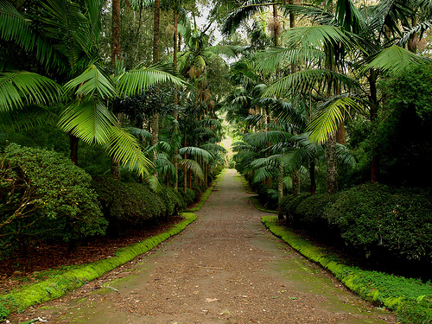
Furnas - This full day tour to Furnas will take you to the lagoa das Furnas where you can see the Furnas Stew, a typical meal cooked with the steam coming from the active volcano; caldeira das Furnas, with 22 thermal springs; a botanical Garden called Terra Nostra Garden, full of endemic plants such as 200 types of camellias, fern garden, azalea woods. Finally, the thermal baths of Poça da Beja will delight your stay.

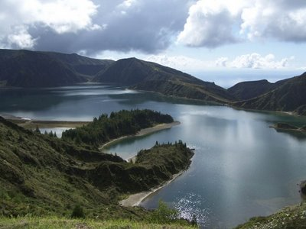
Lagoa do Fogo – This half day tour will give you the possibility to observe the Lagoa do Fogo, a volcanic crater with 1.5km of area, with endemic plants such as laurel, Azorean bilberry trea, trea heath. It’s also possible to see some birds in Lagoa do Fogo, specially, seagulls and common terns. After a small stop in Ribeira Grande city where you can visit the Senhor dos Passos church, a final example of baroque architecture, you will continue in the north coast of the island to visit a unique green tea factory in Europe – Gorreana.

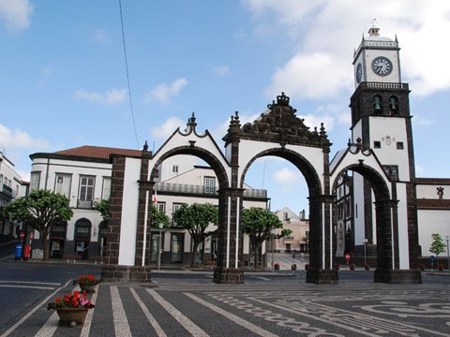
Ponta Delgada – This half day tour to the capital city of Ponta Delgada will be you the possibility to visit many interesting and historical places of the city, such as san Sebastian church, the sanctuary of Esperança, where it takes place the most important religious festivity of the Archipelago – Santo Cristo dos Milagres; the city gate of Ponta Delgada, the local market, the Colegio Church and finally António Borges garden, a final example of botanical gardens.

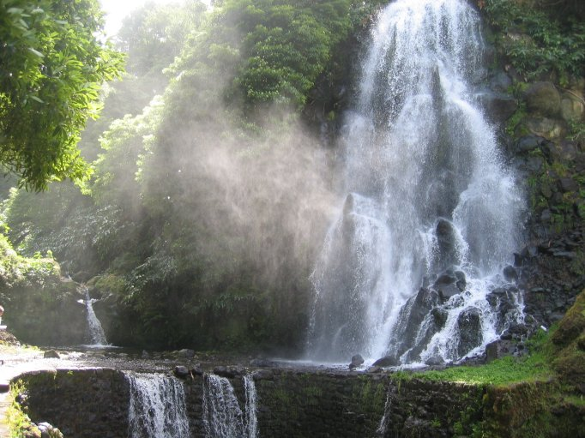

Nordeste – This full day tour will take you to a fantastic experience in this green island: santa iria viewpoint; ribeira dos caldeirões, a lovely waterfall surrounded by hydrangeas and azaleas; the village of Nordeste, considered the garden of Europe; Ponta do Sossego and Pôr do Sol viewpoint.

Adventure and trekking in Sete Cidades

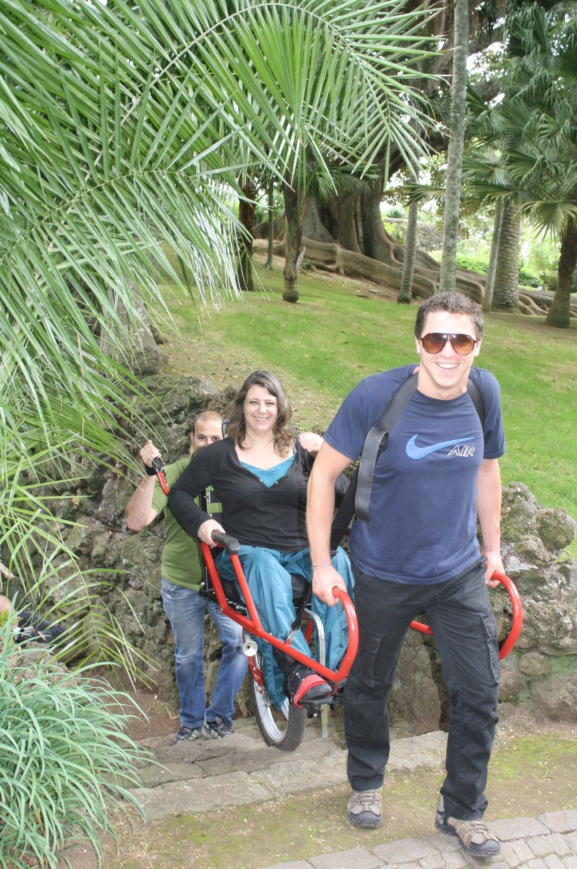
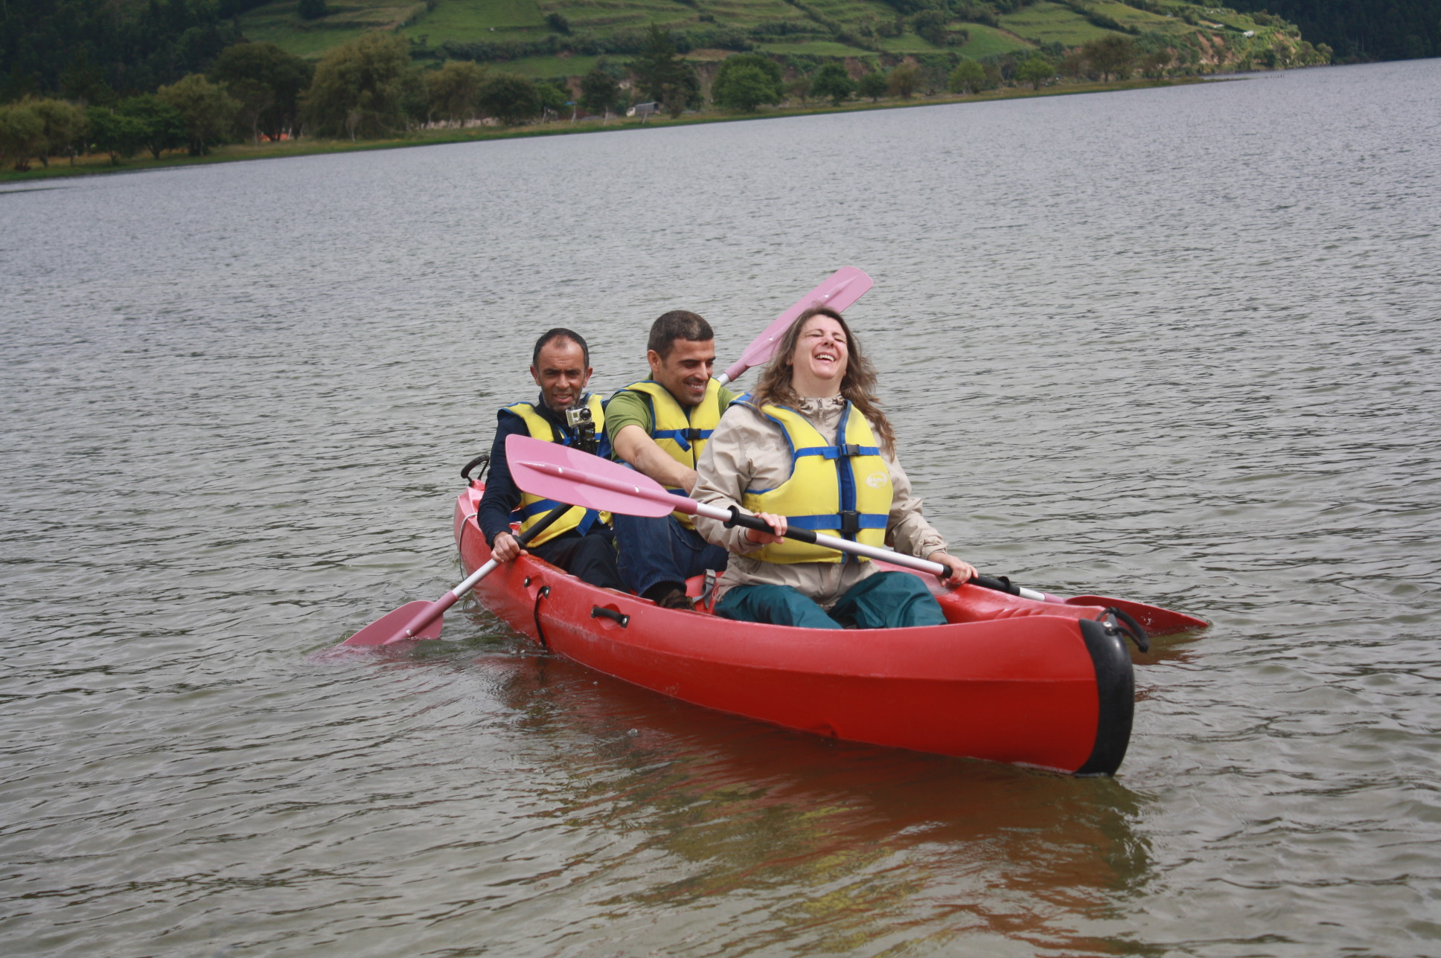
This full day excursion will give you the possibility to experience nature activities. Canoeing in Lagoa das Sete Cidades and a pedestrian walk in the joellete (a appropriate chair for disabled people do pedestrian walks) in António Borges Garden, in Ponta Delgada. Both activities area accessible and appropriate for disabled tourists.

Tours in Terceira

Angra do Heroismo

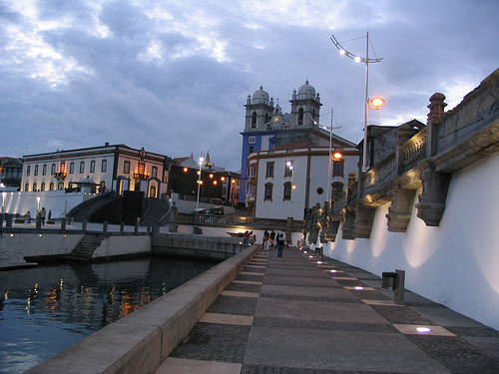
This half day excursion includes: São Gonçalo convent; São Sebastião Castle; Memória viewpoint; the XVI century gothic church – the cathedral and Angra Museum.

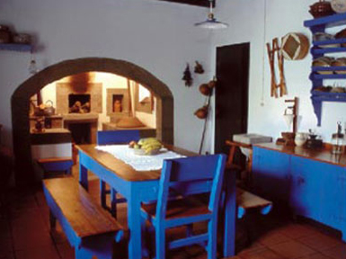
Quinta do Martelo
This half day excursion included a guided visit o Quinta do Martelo, a ethnographic center with educational programmes and a traditional restaurant. This rural accommodation has reconstructed and maintain certain regional aspects such as: workshops, traditional dying out crafts, and houses dating back to the beginning of the Azores settlement. There is also a Farm area to biological agriculture, and preserve autochthonous species of domestic animals for use in the various features of the Farm.

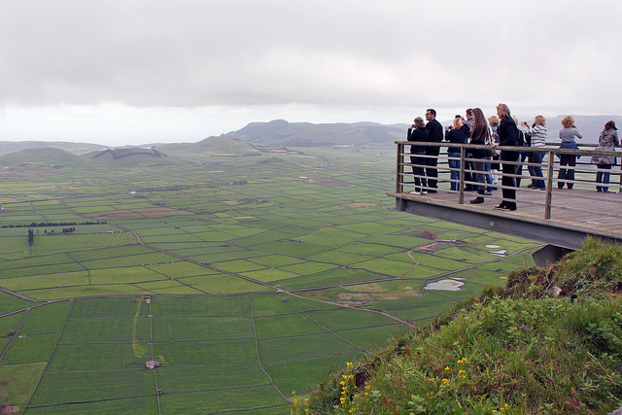
Round island

This full day excursion includes: monte Brasil, Serretinha, Porto Judeu, S. Sebastião, Porto Martins, Praia da Vitória, Serra do Cume, Lagoa das Patas, Lagoa do Negro, Biscoitos (with bath possibility) and the wine museum.

